Your Course Name / Semester
Example - Instructions – Discussions
Discussions provide an active learning environment for you to interact with the content, your peers in your online course and your instructor. Hence, they are a MUST in an online course.
There are two parts for each discussion topic.
- Initial Response for discussion topics
  - Your Initial Response is not considered as Participation
- Participation
  - Please note unless you submit your Initial Response, you will not be able to see others’ responses for you to Participate.
Initial Response
- Each week there will be a Discussion assignment with TWO discussion questions.
- Make sure your response
  - demonstrates thorough understanding of the topic
  - uses proper netiquette
- Should not be more than 150 words
- If you are providing any reference - please provide citation
  - if it is a website - provide the website address too
- Available only for that week.
  - Will open at 12:01 AM MT on Day 1 - Monday morning of the week it is due.
  - You are required to submit your Initial Response to each of the Discussion questions by
    - by 11:30 PM MT on Day 3 - Wednesday
- Your Initial Response is not considered as Participation
- Do not forget to title it "Initial Response - 'First Initial''Last Name'." For example - "Initial Response – JDoe".

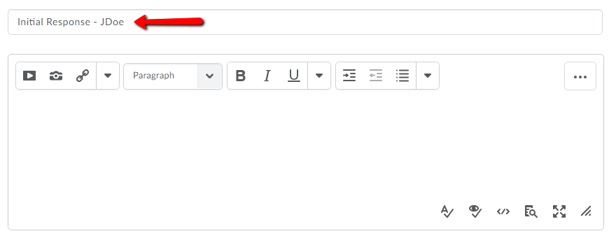

Tips for Initial Response
- Prepare your Initial Response in a Word document or any other word processing program
  - Save a copy for yourself
  - Copy and Paste it in the discussion area
  - Benefits: - Helps to not to lose your work in case
- Do not attach any files to the discussion
Participation
- You are required to respond to TWO of your classmates’ initial responses for both the discussion questions
  - by 11:30 PM MT on Day 7 - Sunday.
    - This means you are responding 4 times in a week.
- Your responses to your classmates’ Initial Responses need to be substantive.
  - Responses like, “I agree,” or “Good point!” are not sufficient.
  - Your response needs to add value to the conversation.
  - You might try offering a different perspective (certainly we don’t all need to agree with one another).
  - You might extend the analysis to another situation.
  - You might clarify a misunderstanding.
  - You might ask a question that pushes the analysis into a new direction.
- Do not forget to address your classmate by name that you are responding to
  - For example: Jonah, I …………..
Note: You can change the Time Zone settings by using the ‘My Settings > Account Settings > Time Zone’ after logging into D2L before entering your course.

